Hillwood Football Club
C/o 14 Millﬁeld View
Erskine PA8 6HE

Telephone: 07817 505 915
Email: hillwood1966@hotmail.co.uk
11/5/22

Dear GMB@SAS

On behalf of Hillwood FC, I would like to take this opportunity to thank you for your generous donation of £200 to Hillwood FC 2007.

As you know Bryan Smith and his fantastic team have since gone on to win the Inspire Scottish Cup and your donation will help them to prepare to defend their title next season

With sincere gratitude

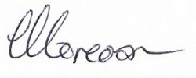

Helen Corcoran
Hillwood FC Secretary

