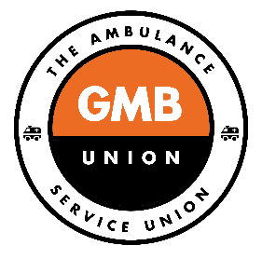

NHS PENSION CHANGES

The NHS pension schemes (1995 and 2008 sections), along with all the other main public sector pension schemes, were reformed in 2015 and everybody - except those closest to retirement - was placed into them. Those members closest to retirement were allowed to remain in the scheme that they were in prior to 2015 (their legacy scheme). This was known as transitional protection.

In December 2018 (following the McCloud judgement) this transitional protection (not the schemes themselves) was found to be age discriminatory.

In July 2020 the government launched a consultation seeking views as to how to remove the discrimination. The consultation set out a procedure whereby everybody, for benefit calculation purposes only, would be returned to their legacy schemes for the period 1st April 2015 to 31st of March 2022 (the remedy period). Then, with effect from 1st April 2022, everybody would be returned to the reformed 2015 schemes.

Upon retirement everyone would be given a choice as to whether they want their remedy period benefits calculated on the basis of their legacy scheme or the reformed 2015 scheme.

FAQs

- If a member of staff retires at 60 after 2022 (e.g. retires in 2026) they will have had their remedy period pension (2015 to 2022) paid as at their legacy scheme (1995) and will then have had 4 years in the new scheme (2015). As they are retiring before the new pension age for the 2015 scheme will they effectively lose the 4 years of contributions they have put into the new scheme?

Members will not automatically have their pension for the remedy period paid in accordance with their legacy scheme. At the point of retirement all members will be given the choice as to whether they want their remedy period pension benefits calculated on the basis of their legacy scheme or the 2015 scheme.

If a member retires on or after the pension age for the legacy scheme but before the pension age for the 2015 scheme, they can choose either NOT to take their 2015 benefits at that time, or claim them with an actuarial reduction for early payment.

Members will be given a statement that shows the value of each and will be asked to decide which they prefer; retrospective adjustments may be made to any benefit already received.

- If a staff member retires at 60, and pays nothing into the new scheme, will they receive the full benefits of the 1995 scheme or will they lose benefits because they are retiring prior to the date they can draw their state pension (which would be 65 or 67?)

Members will receive the benefits of the scheme they were in at the point of their retirement. In the 1995 scheme the Normal Retirement Age is 60. Retiring before age 60 in the 1995 scheme would lead to an (approximate) 4% reduction in the value of the pension for each year retired before age 60.

- The concern from some staff is that if they retire before 67 they will lose some of their 1995 scheme benefits because they are effectively retiring early (prior to the date they can draw their state pension)?

See above. 1995 scheme benefits will only be reduced if one retires before age 60. As stated, they are reduced by (approximately) 4% for each year of early retirement.

- Can you take your 1995 pension and still continue to be employed in the NHS and continue with the 2015/2022 pension?

No. To take your pension you must retire. However, it may be possible to retire and return to work; if you do you are currently not allowed to rejoin a pension scheme.

- Is the 1995 pension scheme closing? If yes, can you still draw on the 1995 pension at 60 when it matures without taking a deficit?

The 1995 section is already closed to new members. It has a Normal Retirement Age of 60 meaning you can retire and draw on it when you reach age 60 without reduction.

- Does this automatically go into the 2015 pension so you can still take it but at a deficit as you would be taking it early?

The pension earnt in the 1995 section of the scheme is an accrued benefit; it is protected and remains in your pension pot until you choose to retire. What you earn in the 2015 section is added to your 1995 accrued benefit. The two sections added together form your pension. If you retire before age 60 the 1995 benefit may be reduced. If you retire before your state pension age your 2015 pension benefits will be reduced.

- When will the 7 years pension pot be enforced/letters to staff?

Given the large numbers of people in the NHS pension scheme - both active and retired - it is unlikely that members will be given the choice before October 2023. If you are already in receipt of your pension at that time retrospective adjustments may be made.

- Can we have clear flow chart or journey tool would be helpful

There is one below and on the GMB website in addition to that which can already be found on www.nhsbsa.nhs.uk

- What would be classed as early retirement in the new scheme?

Retiring before the Normal Pension Age (NPA) of the scheme would be classed as early retirement. The NPA of the 2015 scheme is equivalent to your individual state retirement age (SRA). You can retire at any age up to 10 years before your statement retirement age but your 2015 benefits will be actuarily reduced if you do.

- When are people going to have to make the decision on which pension they want?

At the point of their retirement.

- Are the government/trust/employer going to create a calculator for people to decide easier? Taking into account, age, pay, years in service and grade current and potential future.

Everyone should receive a benefit statement detailing the amount due under each option as part of their Total Reward/Annual benefit statement.

- Can I take my 1995 scheme early without being penalised?

If you retire before the age of 60 in the 1995 scheme you will receive an actuarial reduction equivalent to approximately 4% of the value of your pension for each year you retire early. (unless you have Special Class or Mental Health Officer status with the ability to retire with full benefits from age 55).

- Can I go at 60 with the 95 scheme? What would happen to the pension I pay in from 2022 would it be frozen until I’m 67/68?

You can retire at 60 and claim your 1995 benefits and choose whether to leave your 2015 benefits until state pension age or claim them early; if you claim them early they will be subject to an actuarial reduction for early payment.

- If somebody wants to retire on their legacy scheme before 2022 considering the ruling that was in the 1995 pension scheme when will their figures be available to them?

It is only possible to retire on the basis of the scheme that you are in at the time of your retirement. Figures are available at any time via www.nhsbsa.nhs.uk and you should also be provided with a Total Reward/Annual Benefit Statement that shows an estimate of your likely pension.

- What’s happening to the overpayments from the 2015 scheme?

These are subject to a judicial review which may be heard later this year

- What happens to staff that have retired and returned? Will the ruling affect their lump sum and payment?

All pensioners who retired between 2015 and 2022 will be given the option to change their benefit calculation under this remedy arrangement if it is advantageous for them to do so. These are called “immediate cases” and it is anticipated that the NHS Pension scheme will contact these members as soon as possible after that legislation is enacted (April 2022) if not before.

There are currently no plans to alter the lump-sum provisions.

- Will the 2015 scheme become the 2022 scheme?

Effectively, yes. However, there is no plan to call it the 2022 scheme, it will remain known as the 2015 scheme

- There is a rumour of the changes in April 2022 regarding the lump sum you get when you retire - that this is going to change on this date. Also have we been put back into the 1995 scheme as I heard we had been moved over to the latest scheme. Again, I heard the Fire/Police had won their case and so automatically we should follow and go back into the 1995 scheme.

There are currently no plans to alter the lump-sum provisions.

You will be put back into the 1995 scheme for benefit calculation purposes only for the period 1st April 2015 to 31st March 2022. This is as a consequence of the recent Firefighters victory

- What happens to the ERRBO scheme will it continue in the 2022 scheme and if not, what happens to monies previously paid in?

ERRBO will continue as it is now – details are here

https://www.nhsbsa.nhs.uk/sites/default/files/2019-07/Early%20retirement%20reduction%20buy%20out%20%28ERRBO%29%20factsheet%20-20190711-%28V9%29%20%20%20%20%20%20%20.pdf

- Will my Remedy Period benefits be calculated on the basis of my final salary as at 31st March 2015 or the salary at my retirement date?

As long as you have not had a break in service they will be calculated on the basis of your final salary as at the point of your retirement; if you have had a break in service then they will be calculated on the basis of your salary at the time the service was broken.

- Can I retire and re-join the pension scheme?

No, current regulations mean that you cannot re-join the scheme unless you retired on ill health and returned before the minimum pension age of the scheme i.e. 10 years before your state retirement age. However, in the 2015 scheme you can draw down part of your pension while still paying into it.

- Is there a cost to Benefit statements?

Annual Benefit statements and Total Rewards Statements are issued free of charge. NHSBSA charges for information requested over and above the information contained in the ABS and TRS. See this link for full details: AW295 GP IP2016 (nhsbsa.nhs.uk)

Additional Information

The following websites may also provide you with relevant information:

- A full guide for members can be found here

https://www.nhsbsa.nhs.uk/sites/default/files/2019-03/2015%20Members%20Guide%20%28V10%29%2002.2019.pdf

- Click below to see how much your 2015 section will be reduced by if you retire before the NPA

https://www.nhsbsa.nhs.uk/sites/default/files/2017-03/2015%20VER-ARER%20factors%20V4%20%2810.2015%29.pdf

- Videos and factsheets on retire / return - Applying for your pension | NHSBSA

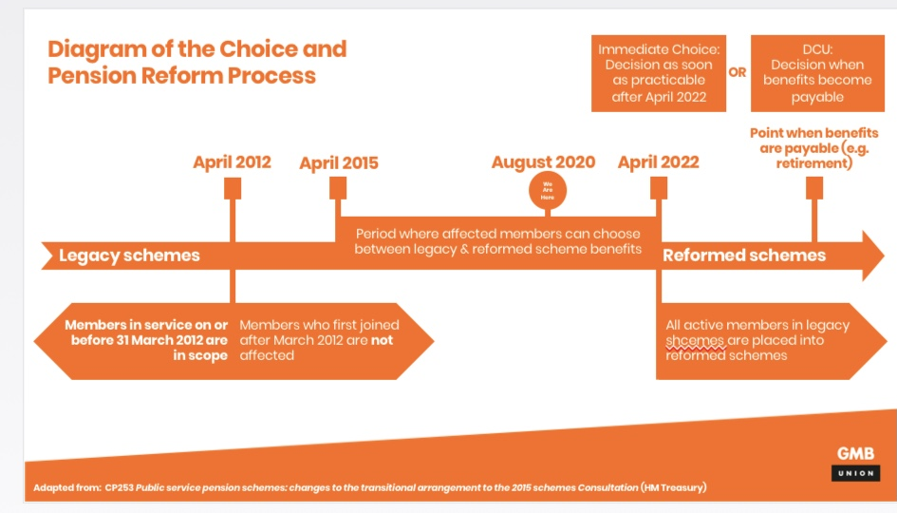

George Georgiou
GMB National Pensions Organiser
george.georgiou@gmb.org.uk
March 2021

